CALCULATING FAMILY EXPENSES

**TEAM ID:** NM2025TMID20216

**TEAM MEMBERS: 3**

**TEAM LEADER: GAYATHRI S MEMBER: MONISHA R MEMBER: ARCHANA K**

**PROJECT STATEMENT:** This Service Now project aims to streamline and improve how users

manage family-related financial activities. It will offer features such as expense tracking, category management, budget planning, real-time monitoring, and detailed reporting. Leveraging Service Now’s powerful and flexible platform, the project will deliver a user-friendly, scalable solution that fits different family sizes and financial needs. The ultimate goal is to equip users with the tools to make smart financial decisions and enhance overall financial well- being within the family unit.

**Objective :** The " family expensive project " phrase seems to be a misunderstanding, but if referring to Service Now’s Strategic Portfolio Management (SPM) , also known as Project Portfolio Management (PPM), its objective is to strategically manage and optimize a portfolio of projects by aligning them with business goals, providing real-time visibility into performance, and improving agility and resource allocation to deliver maximum customer value.

**Skills:** Service now Family expenses IOT Open Hardware platforms, Data Structures

**TASK INITATION**

**MILESTONE 1: A NEW UPDATE SET**

**ACTIVITY 1: CREATE NEW LOCAL UPDATE SET**

1. Open service now
2. Go to All → search for Local Update set → click on New.

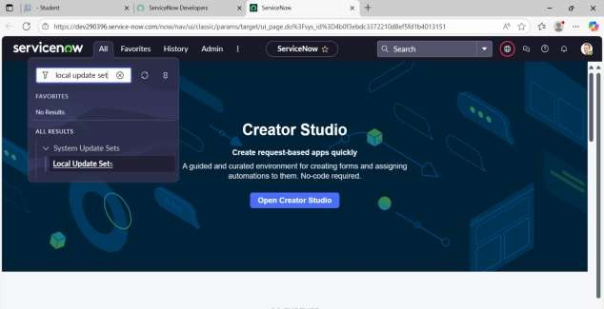

1. Enter the details as:

Name: Family Expenses

1. Then click on Submit and Make current.

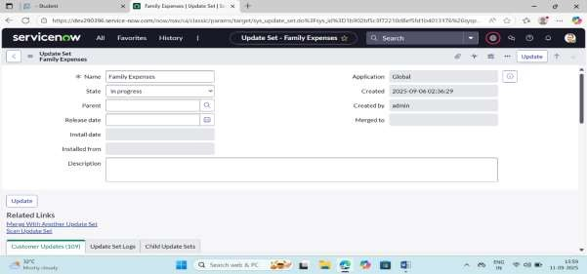

# MILESTONE 2: CREATE TABLE

**ACTIVITY 1: CREATION OF FAMILY EXPENSES TABLE**

1. Go to All → search for Tables → click on New.
2. Enter the Details:

Label: Family Expenses Name: Auto-Populated

New menu name: Family Expenditure

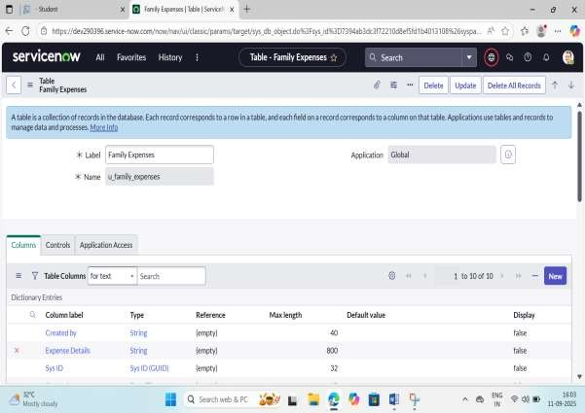

1. Go to the Header and right click there>> click on Save.

# ACTIVITY 2: CREATION OF COLUMNS FIELD

1. Near Columns Double click near insert a new row.
2. Give the details as: Column label: Number Type: String
3. Double click on insert a new row again
4. Give the details as: Column label: Date Type: Date
5. Double click on insert a new row again
6. Give the details as: Column label: Amount Type: Integer
7. Double click on insert a new row again
8. Give the details as:

Column label: Expense Details Type: String

Max length: 800

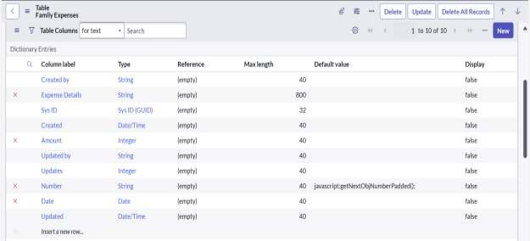

1. Go to the Header and right click there>> click on Save.

# ACTIVITY 3: MAKING NUMBER FIELD AN-AUTO NUMBER

* 1. Double click on the Number Field/Column.
  2. Go down and double click on Advanced view
  3. In Default Value:

Use dynamic default: check the box

Dynamic default value: Get Next Padded Number

* 1. Click on Update.

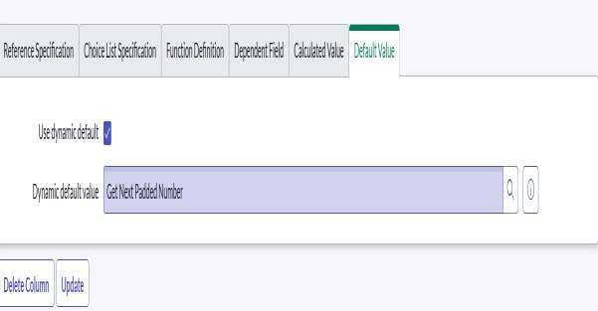

* 1. Go to All → In the filter search for Number Maintenance → select Number Maintenance
  2. Click on New.
  3. Enter the below Details: Table: Family Expenses Prefix: MFE
  4. Click on Submit.

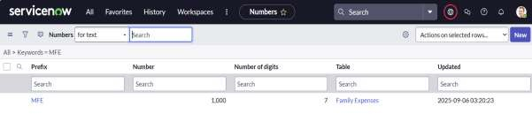

# ACTIVITY 4: CONFIGURE THE FORM

1. Click All → Search for Family Expenses → Open Family Expenses.
2. Click on New.
3. Go to the Header and right click there→click on Configure → Select Form Design
4. Customize or Drag Drop the form as per your requirement.

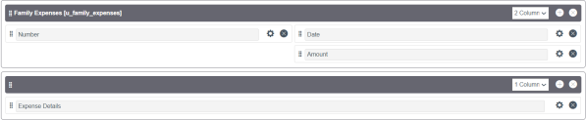

1. Make Number Read-Only Field by clicking on the gear icon and checking Read-Only.
2. Make Date, Amount Mandatory Field by clicking on the gear icon and checking Mandatory.
3. Click on Save.

# MILESTONE 3: DAILY EXPENSES TABLE

**ACTIVITY 1: CREATION OF TABLE (DAILY EXPENSES)**

1. Go to All → search for Tables click on New.
2. Enter the Details: Label: Daily Expenses Name: Auto-Populated

Add Module to menu: Family Expenditure

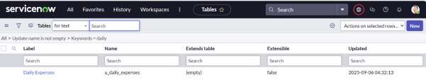

1. Go to the Header and right click there>> click on Save

# ACTIVITY 2: CREATION OF COLUMNS (FIELD)

1. Near Columns Double click near insert a new row.
2. Give the details as:

Column label: Number Type: String

1. Double click on insert a new row again
2. Give the details as:

Column label: Date Type: Date

1. Double click on insert a new row again.
2. Give the details as:

Column: label Expense

Type: Integer

1. Double click on insert a new row again.
2. Give the details as:

Column label: Family Member Name Type: Reference

Max length: 800

1. Double click on insert a new row again.
2. Give the details as:

Column label: Comments Type: String

Max length: 800

1. Go to the Header and right click there → click on Save.

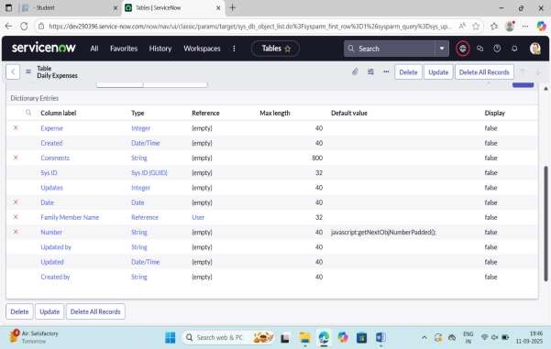

# ACTIVITY 3: MAKING A NUMBER FIELD AN AUTO-NUMBER

1. Double click on the Number Field/Column.
2. Go down and double click on Advanced view
3. In Default Value:

Use dynamic default: check the box

Dynamic default value: Get Next Padded Number

1. Click on Update.



1. Go to All → Search for Number Maintenance → select Number Maintenance
2. Click on New.
3. Enter the below Details: Table: Family Expenses Prefix: MFE

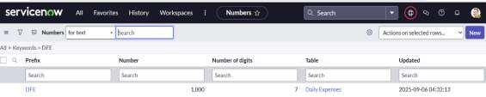

1. Click on Submit.

# ACTIVITY 4: CONFIGURE THE FORM

1. Go to All →Search for Daily Expenses → Open Daily Expenses
2. Click on New
3. Go to the Header and right click there → click on Configure → Select Form Design
4. Customize or Drag Drop the form as per your requirement.
5. Make Number Read-Only Field by clicking on the gear icon and checking Read-Only
6. Make Date, Family Member Name Mandatory Field by clicking on the gear icon and checking Mandatory
7. Click on Save.

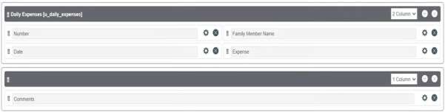

# MILESTONE 4 : CREATION RELATIONSHIP

**ACTIVITY 1: CREATION RELATIONSHIP BEWTEEN FAMILY EXPENSES AND DAILY EXPENSES TABLE:**

1. Go to All → search for Relationships → Open Relationships.
2. Click on New.
3. Enter the details: Name: Daily Expenses

Applies to table: Select Family Expenses Daily Expenses: Select Daily Expenses

1. Click Save.

# MILESTONE 5: CONFIGURING RELATED LIST ON FAMILY EXPENSES

1. Go to All → Search for Family Expenses → Open Family Expenses
2. Click on New
3. Go to the Header and right click there → click on Configure → Select Related Lists
4. Add Daily Expenses to the Selected Area.
5. Click on Save

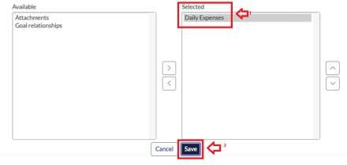

# MILESTONE 6: CREATION OF BUSINESS RULE ACTIVITY 1: CREATION BUSINESS RULE

1. Go to All → Search for Business Rules.
2. Click on New.
3. Enter the Details:

Name: Family Expenses BR Table: Select Daily Expenses

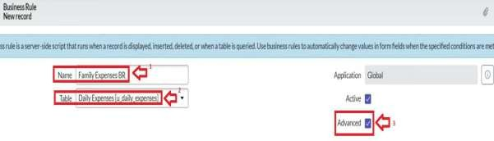

1. In when to run Check Insert and Update

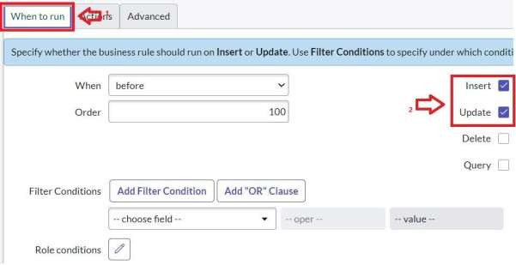

1. In Advance (we write the code): Write the below code >>

( function execute Rule (current, previous /*null when async*/) {

var Family Expenses = new Glide Record (' u_family_expenses '); Family Expense. Add Query ('u_ date',current.u _ date);

Family Expenses. Query (); If (Family Expenses.next(())

{

Family Expenses .u _amount += current .u_ expense;

Family Expenses .u_ expense_ details += ">"+current. u comments+":"+"Rs.”

+ current . u _ expense+"/- "; Family Expenses. update ();

}

else

{

var New Family Expenses = new Glide Record('u_ family_ expenses'); New Family Expenses. u _ date = current. u _ date;

New Family Expenses. u _ amount = current. u _ expense; New Family Expenses .u_ expense_ details+=">"+current.u_comments+":"+"Rs."+cu rrent.u_expense+"/-"; New Family Expenses.

Insert ();

}

})( current, previous);

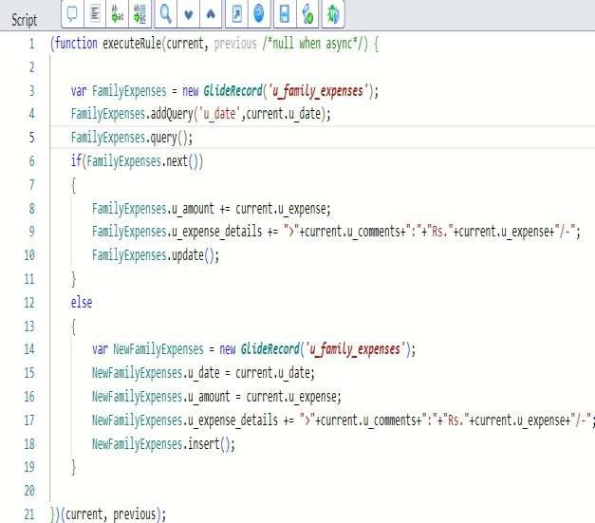

1. Go to the Header and right click there → click on Save.

# MILESTONE 7: CONFIGURE THE RELATIONSHIP ACTIVITY 1: CONFIGURE THE RELATIONSHIP

* 1. Go to All → Search for Relationships → Open Relationships.
  2. In that, open Daily Expenses Relationship.
  3. For Applies to table: Select Family Expenses.
  4. In Query with: write the below Query.

(function refine Query (current, parent) {

// Add your code here, such as current. add Query (field, value); current. add Query ('u_ date', parent. u_ date);

current. Query ();

}) (current, parent);

1. Click on Update.

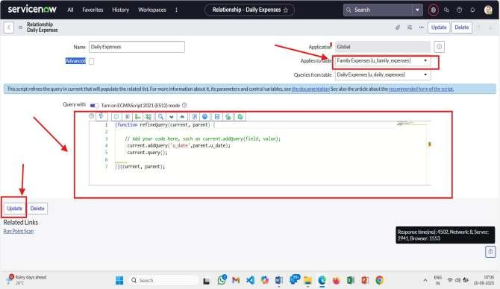

# CONCLUSION:

A successful Service Now project shows real business value by aligning with company goals, improving processes, and making the user experience better. This happens through expert planning, clear process mapping, smart use of configuration instead of heavy customization, and open, honest communication. With strong project management and risk control, the implementation delivers clear results, a solid return on investment, and sets the stage for future improvements.